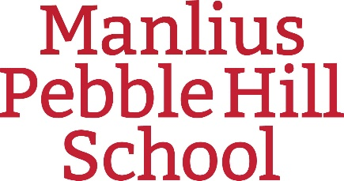

Information Regarding Medication on Field Trips

Dear Parents/Guardians,

In order to provide the safest environment for our students while on any field trip, Manlius Pebble Hill School will follow the regulations and guidelines set forth by New York State Public Health Law. Please note the following procedures for the administration of any medication during a field trip:

- The Administration of Medication Authorization form requires the signature of both a healthcare provider and a parent/guardian. If your child will need any medication(s) while on a fieldtrip, the Administration of Medication Authorization form must be completed. If you already have this form on file in the Health Office and it includes all of your child’s current medications, then you do not need the form signed again.

- All medicine sent to the chaperone must be in the original container and labeled with
the following information: name of student, exact dosage, time and frequency to take
medicine, and reason for medication. Medicine should be placed in a Ziploc bag and
labeled with the child’s name.

- There will be no “stock” bottles of medicine provided. Parents must provide their child’s
medicine.

- A student will not be allowed to “self-carry” any medication unless the appropriate circle is checked on the form. The chaperone will carry and supervise all medications if neither circle is chosen.

If you have any questions regarding any medical forms or MPH medical policies, please contact:

Christine Civello, RN
MPH School Nurse
315.446.2452 ext. 127
315.383.4792 (cell)
1.866.846.0684 (fax)
ccivello@mphschool.org

Thank you for your cooperation.

