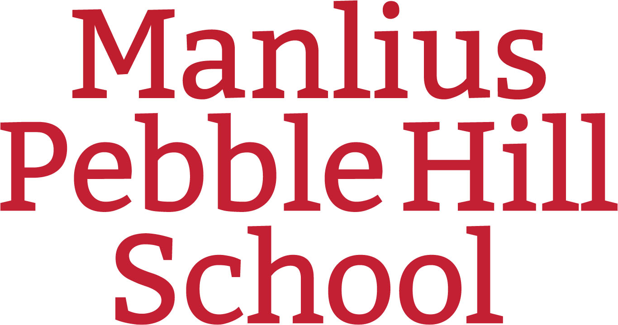

COLLEGE PLANNING GUIDE FOR RISING SOPHOMORES
MANLIUS PEBBLE HILL SCHOOL

General Advice to Students:
- Concentrate on academic preparation.
  - Be "on top" of your academics. Meet with teachers for additional help.
  - If you have a documented learning difference, contact the director of academic support
- Continue to develop academic skills through reading, writing, and improving study habits.
- Sign up for co-curricular activities that interest you.
o Level of involvement/accomplishment is most important, not the number.
o Keep a record of your involvement, volunteer work, and employment.
- Save your best work in academic courses and the arts for your academic portfolio.
- Get informed about college costs. Explore your family's options for financing your child's college education and learn how financial aid works. Use an online College Cost Calculator: www.studentaid.gov Info on financing a college education www.federalstudentaid.org & attend SmartTrack College Funding What Parents Need to Know Now About Paying Less for College Webinar in late April..

Fall Semester:
- In October, MPH offers the PSAT to Sophomores. Although typically 90-95 percent of the sophomore class takes the test, it is not mandatory. The PSAT is a preliminary test that prepares you for the SAT. Scores are not reported to colleges.
- If you do not want to take the PSAT, simply inform the college counseling office.
- When you receive your PSAT results, use the on-line report to explore ways to improve on future standardized tests. Free online test prep is offered through SAT partner Khan Academy.

Spring Semester:
- In March, review the four-year curricular plan, talk with teachers, adjust, and sign up for appropriately challenging junior year courses.
- In April, all sophomores will take the pre-ACT test. When you receive your pre-ACT results, use the on-line resources to explore ways to improve on future standardized tests. Free online test prep is offered through ACT partner Kaplan.
- Plan for wise use of the summer.
o Enroll in a summer course or special program of interest to you. Expand on service learning and volunteer opportunities.
o Continue with co-curricular passions.
o Seek summer employment.

